Exp No:5 Title of the Exercise: Reader-Writer problem

Date:19/09/2022

Aim:

Implementation of Reader-Writer problem

Procedure:

The readers-writers problem relates to an object such as a file that is shared between multiple processes. Some of these processes are readers i.e., they only want to read the data from the object and some of the processes are writers i.e., they want to write into the object. The readers-writers problem is used to manage synchronization so that there are no problems with the object data. For example - If two readers access the object at the same time there is no problem. However, if two writers or a reader and writer access the object at the same time, there may be problems.

To solve this situation, a writer should get exclusive access to an object i.e. when a writer is accessing the object, no reader or writer may access it. However, multiple readers can access the object at the same time.

Code: --

#include<semaphore.h>

#include<stdio.h>

#include<stdlib.h>

#include<unistd.h>

#include<pthread.h>

sem_t x,y;

pthread_t tid;

pthread_t writerthreads[100],readerthreads[100];

int readercount = 0;

void *reader(void* param)

{

sem_wait(&x);

readercount++;

if(readercount==1)

sem_wait(&y);

sem_post(&x);

printf("%d reader is inside\n",readercount);

usleep(3);

sem_wait(&x);

readercount--;

if(readercount==0)

{

sem_post(&y);

}

sem_post(&x);

printf("%d Reader is leaving\n",readercount+1);

return NULL;

}

void *writer(void* param)

{

printf("Writer is trying to enter\n");

sem_wait(&y);

printf("Writer has entered\n");

sem_post(&y);

printf("Writer is leaving\n");

return NULL;

}

int main()

{

int n2,i;

printf("Enter the number of readers:");

scanf("%d",&n2);

printf("\n");

int n1[n2];

sem_init(&x,0,1);

sem_init(&y,0,1);

for(i=0;i<n2;i++)

{

pthread_create(&writerthreads[i],NULL,reader,NULL);

pthread_create(&readerthreads[i],NULL,writer,NULL);

}

for(i=0;i<n2;i++)

{

pthread_join(writerthreads[i],NULL);

pthread_join(readerthreads[i],NULL);

}

}

Output: --

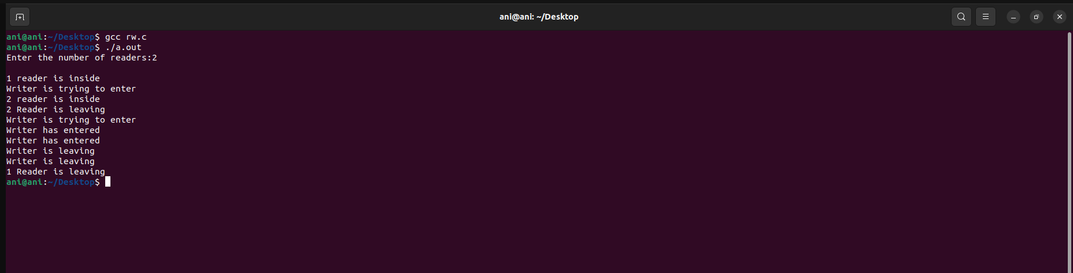

Result: --

Thus we come to know about Implementation of Reader-Writer problem using c.